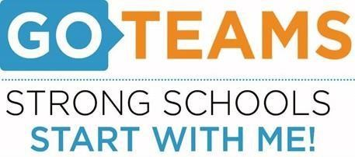
School | Date | Time | Location
BEST Academy (6-12) | 3/10/22 | 5:00pm | Zoom Call
Notice Prepared By: Dr. Timothy Jones Date Posted: March 8, 2022 Revised: 3/7/22

Meeting Agenda
(Agenda may be amended)
This meeting will allow for Public Comment
Join Zoom Meeting: https://atlantapublicschools-us.zoom.us/j/82681561524?pwd=WVh1TlViejE1aHhtNC8xU0NjR2R3Zz09
- Start Recording
- Call to Order
- Roll Call; Establish Quorum
- Action Items
Budget Training for members who have not completed training Elis
Discussion Items
- BEST budget for the 2022-2023 school year
1. Review the Budget Development Presentation given at the Budget Feedback Meeting
2. Review any changes to the budget that occurred in the staffing conference:
3. Present any additional proposed changes and/or tradeoffs in the budget

- Information Items
- Public Comments – N/A
- Announcements
- NO School (PD) – March 21st
- Wednesday, March 27th - 2022 State of the Douglass Cluster Meeting (6:00 – 7:00pm)
- Next Meeting April 14th – via Zoom
- Adjournment

